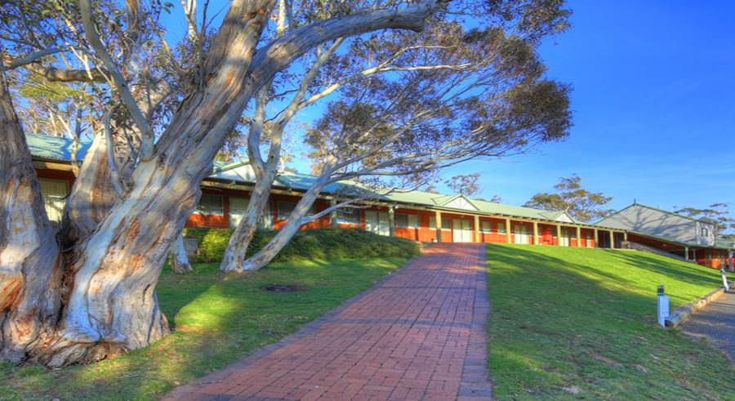
SINGLE ADVENTIST MINISTRIES NATIONAL CONVENTION
Friday 30th DEC 2022 - Tuesday 3rd JAN 2023
WHERE: Adventist Alpine Village, 122 Tinworth Drive, Jindabyne NSW

KEYNOTE SPEAKER: PR DARREN CHEERS
THEME: DEVELOPING HEALTHY RELATIONSHIPS

FULL ACCOMMODATION & MEALS: $390
EARLY BIRD FEE: $360 UP TO 25th OCT. 11pm

APPLY ONLINE 25th July, 11am CLOSE 12th December 2022, 11pm

Link to Registration: https://events.adventist.org.au/event/info/7208

SAVE THE DATES, START PLANNING, ORGANIZE TO CARPOOL CELEBRATE NEW YEAR’S EVE WITH FRIENDS!
Enquiries AUCSAM Registration Coordinator: snswsinglesministries@adventist.org.au OR Wilma Falcke 0424 097 484 (AH or Text)
